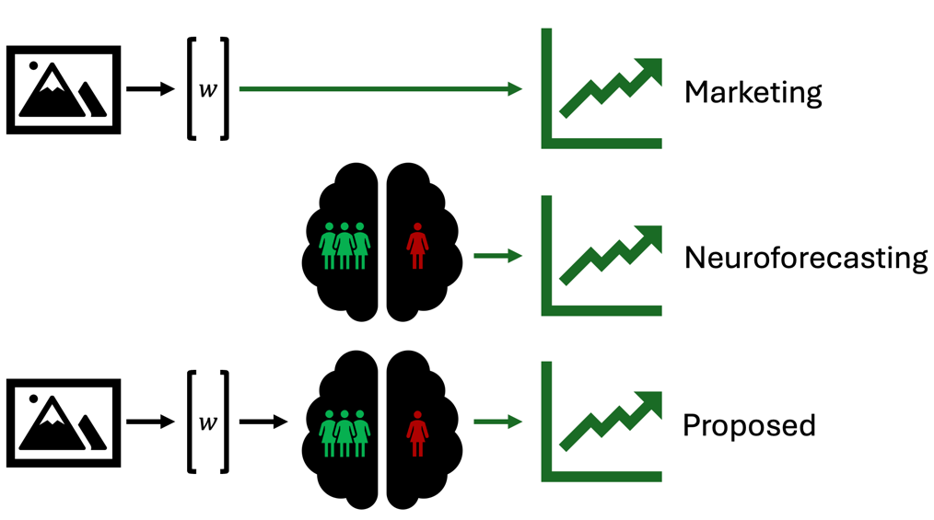
Figure 1. Machine learning methods in marketing have demonstrated improved demand forecasting using latent features from product images. Neuroforecasting has demonstrated that activity in the nucleus accumbens of a small sample forecasts market-level outcomes. We propose a combination of these methods, using the latent features from machine learning to suggest potential drivers of nucleus accumbens activity.

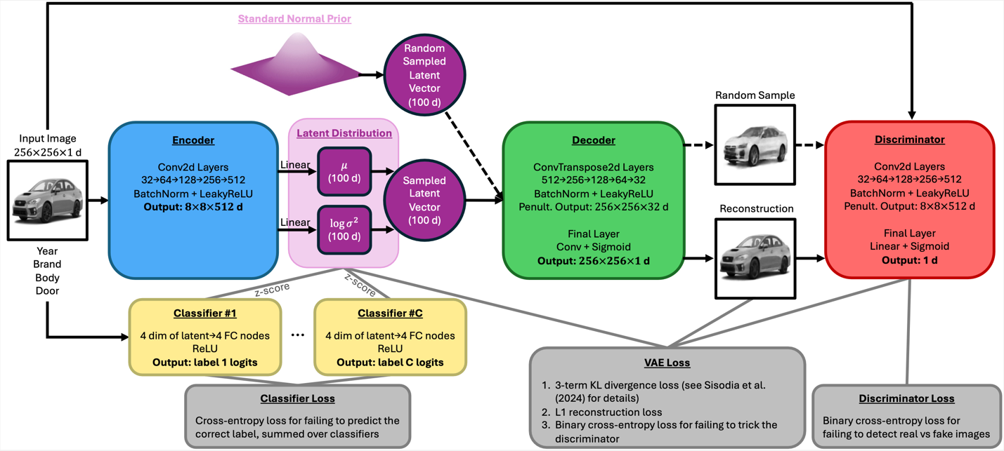
Figure 2. MotorVAEGAN, our custom variational autoencoder. The full network is comprised of an encoder, decoder, discriminator, and classifier networks. The latent vector for each image provides us with a set of latent visual features that we can use to correlate with neural activity. Classifier networks predict labels associated with each image and aid with “disentanglement” (i.e. ensuring that each dimension in the latent vector is encoding a single, unique visual feature).

